**DESIGN, DOMAIN, AND PACKAGE DIAGRAM**

This document includes the Design Domain and Package diagram which helps in better understanding of the project.

1. Design Diagram-

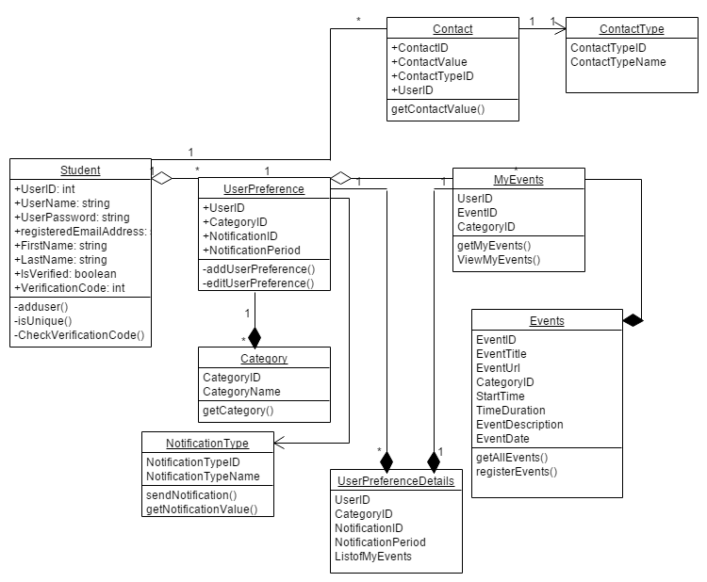

2. Domain Diagram -

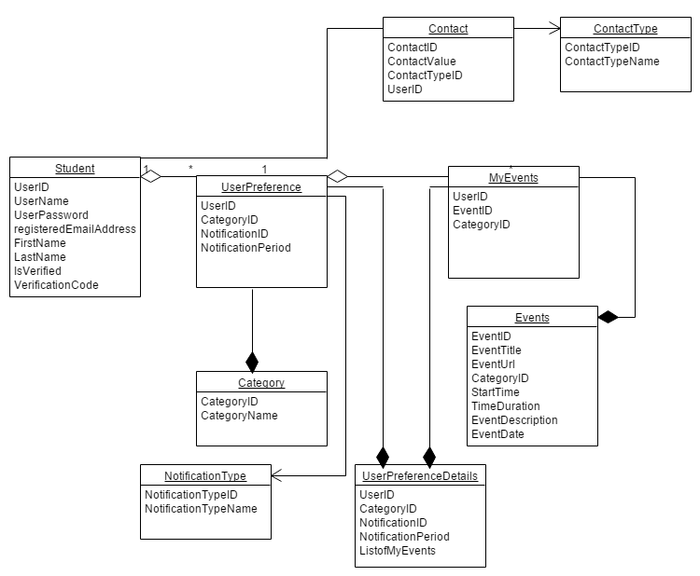

3. Package diagram -

